Great Bradfords Junior School
Parent Handbook

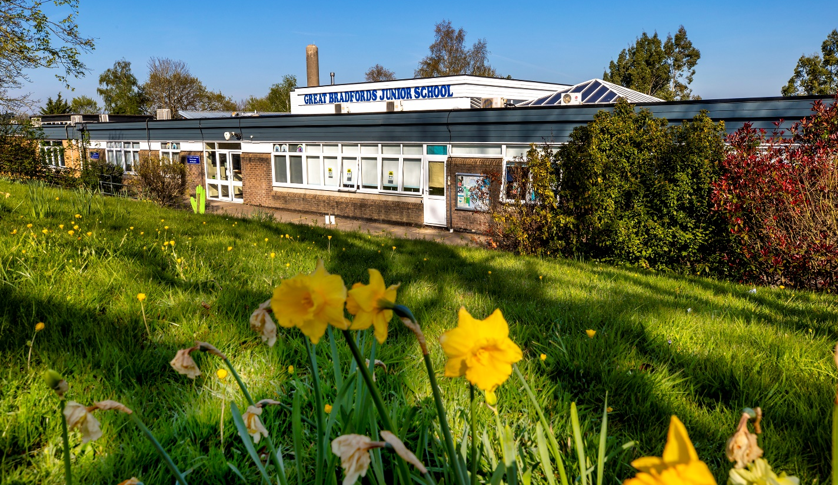



Contents

Page 3 Introduction
Page 4 Mission, Aims and Code of Conduct
Page 5 Our School Staff

Learning information:

Page 6/7 Our Curriculum
Page 8 Special Educational Needs
Page 9 Learning Behaviours
Page 10 Restorative Practice
Outside Learning
Page 11 Positive Playtimes
Page 12 Celebrating Success
The Bradford Mile & Walk to School Challenge
Page 13/14/15 The software we use
Page 16 Homework
Page 17 Pupil Voice in Action
Page 18 Working together as a community

Parent Information:

Page 19 Clubs
Page 19 Our School Day
Page 20 Medical Matters
Page 21 Uniform
Page 22 P.E. Kit
Page 23 Other important equipment
Page 24 Absence Procedures
Page 25/26 Admissions and Leavers Processes
Page 27 Contacting the school
Page 28 Site map

Introduction

We are a friendly, three-form entry junior school (Year groups 3 – 6) that puts the education and wellbeing of our children at the heart of everything we do. We are an enthusiastic, approachable and caring community underpinned by a hard-working, welcoming and creative team of teachers and support staff, who make learning fun!
Our school motto is ‘Together we learn; together we grow’ and our Code of Conduct is: be safe, be kind, be responsible. We are a values-based learning community committed to the education of the whole child and are always seeking new and creative ways of engaging children in learning experiences that motivate and entice them to deepen their understanding.
We are passionate about providing an exciting and purposeful curriculum and strive to achieve high academic standards for all children. We believe this is best achieved through teaching that is engaging, innovative and personalised to children’s needs. Our ambition is to prepare the children for the modern world, promoting and developing curiosity, independence and resilience. However, most importantly, we are proud of our school’s caring ethos, ensuring the children are happy, safe and develop an enthusiasm for a life-long love of learning.
We look forward to welcoming you to Great Bradfords Junior School.

Mr Justin Wrench (Headteacher) and the Great Bradfords’ Team

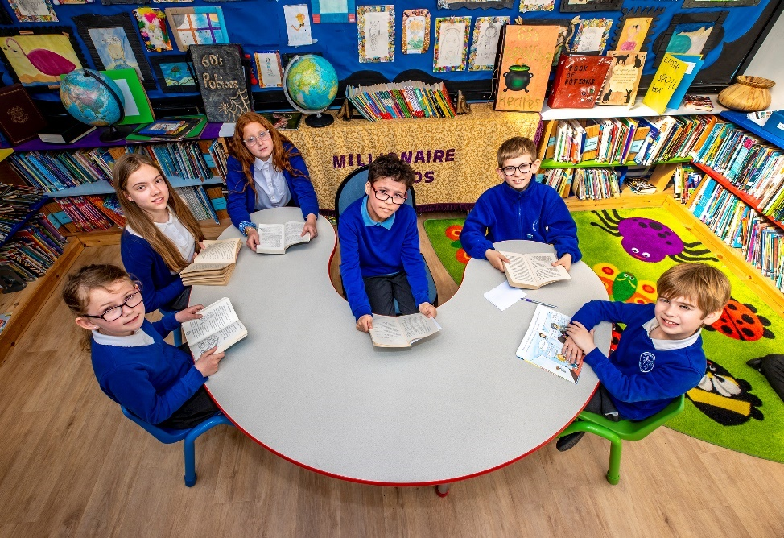

Our mission: to enable everyone to achieve EXCELLENCE

Aims
As a safe and secure learning community, we aim to fulfil our mission by:
- Providing a broad, balanced and purposeful curriculum
- Motivating all children to become independent learners
- Developing the skills to be a lifelong learner
- Encouraging an active lifestyle
- Recognising and celebrating successes

Code of Conduct: Be Safe; Be Kind; Be Responsible
Be Safe:
- We enjoy and look after our environment
- We know where to go for help
- We know everyone respects our Code of Conduct
- When we behave in a safe way, everyone around us is safe

Be Kind:
- We smile and make everyone feel welcome
- We care and look after each other
- We are friendly towards everyone in our school
- We are all different, but equal

Be Responsible:
- We make good choices and wise decisions
- We try our best in our learning
- How we behave and what we do matters
- We treat others as we wish to be treated

Our School Staff (2025/2026)
Headteacher | Mr J. Wrench
Deputy Headteacher | Mrs B. Thompson
SENDCo | Mrs V. Cook-Abbott
Teachers | Mrs S. Buitekant
Teachers | Mr S. Cleary | Mr N. Quilter
Teachers | Mrs E. Collins | Mr A. Sime
Teachers | Mr A.Cumpstey | Mrs M. Smith
Teachers | Mrs L. Donaldson | Mr B. Stevens
Teachers | Mrs K. Drake | Mrs J. Stewart
Teachers | Mrs R. Iqbal | Mr R. Tillsley
Teachers | Mrs R. Mecklenburgh | Mrs J. Walker
Teachers | Miss S. Miah
Administration  & Finance | Mrs A. Dickens
Administration  & Finance | Mrs T. Hart
Administration  & Finance | Miss B. Hawtin
Administration  & Finance | Mrs H Locke
Behaviour & Pastoral Support | Mrs C. Staton
Behaviour & Pastoral Support | Mrs S. Taylor
Behaviour & Pastoral Support | Mrs S. Wrench
Learning Support | Mrs N. Beckett (HLTA) | Mrs S. Price
Learning Support | Mrs S-J. Bennett | Mrs A. Rice
Learning Support | Mrs S. Canning | Miss M. Robbins
Learning Support | Mrs C. Gilhooly | Mrs C. Saunders (HLTA)
Learning Support | Mrs C. Hughes (Cover Supervisor) | Mrs K. Smith
Learning Support | Mrs J. Lynch | Mrs C. Staton
Learning Support | Mrs S. Morris (Cover Supervisor) | Mrs A. Thorne
Learning Support | Mrs B. Page | Miss S, Turner
Learning Support | Mrs J. Penman | Mrs S. Wrench
Learning Support | Mrs A. Perrin | Mrs M. Yates
Mid-day Assistants | Mrs K. Dick | Mrs K. Smith
Mid-day Assistants | Mrs C. Gilhooly | Mrs S. Stredder
Mid-day Assistants | Miss B. May | Mrs E. Turner
Mid-day Assistants | Mrs B. Page | Miss M. Willcox
Mid-day Assistants | Mrs Z. Skews | Mrs Yates
Catering | Mrs C. Bowden | Miss S. Mills (Catering Manager)
Catering | Miss D. Mayhew | Mrs C. Steele
Catering | Miss J. Mayhew
Premises | Mr D. Penman (Site Manager) | Miss D. Mayhew
Premises | Mrs K. Dick | Mrs Z Skews
Premises | Miss C. Eaton | Miss M. Willcox
Premises | Miss S. Egg

Our Curriculum
Together we learn; together we grow
“If you’re going to do something, I believe, you should do it well. You should sweat over it and make sure it’s strong and accurate and beautiful and you should be proud of it”
Ron Berger
At Great Bradfords Junior School, we provide a creative, engaging, inspirational and purposeful curriculum, designed with the ambition to give all learners: the knowledge, skills, confidence to succeed in life and an enthusiasm for learning, adjusting to meet the needs of every child.
Our curriculum is skills based and knowledge rich; we believe that our children should have the opportunity to study areas of the curriculum in greater depth. We want our children to produce excellent outcomes whilst developing their independence, creativity, enthusiasm and resilience. Through our projects, we aim to produce collaborators, innovators, leaders and, more than anything else young people who are kind, safe and responsible citizens.
‘’Excellence is not a skill; it's an attitude.’’ Ralph Marston
At the core of our curriculum we strive to develop the ethic of excellence. We develop a Growth Mindset to help grow excellence for every child. Through our carefully planned projects, all children are assigned meaningful work that matters and they study examples of excellence across a range of subject areas. The environment displays excellent outcomes, which have been created by providing the children opportunities to produce multiple drafts, utilising the culture of critique. All of our projects provide purposeful outcomes or showcases for public presentation either within our school or the wider community.
To shift our children’s thinking, through our project-based curriculum, we drip-feed aspiration and opportunity from the moment they enter to the moment they leave.
Concepts:
Concepts give us the opportunity to create the togetherness amongst our community and connect our curriculum. The concepts lift us above the content of the project to a position where children can start to see things from a wider perspective. Along with this, concepts tap into the personal learning and develop thinking skills. Developing ‘empathy’, discovering a ‘commitment to justice’ or enabling children to recognise that they can have an impact of their ‘environment and community’ does not solely happen by delivering the curriculum, but does happen when we filter the content through our concepts. Concepts allow for connections to be made across subjects across the school. For example, ‘democracy’ can be explored across many eras of history. We have been inspired by the work of Jonathan Lear in developing concepts within our curriculum.

The ‘Big’ Enquiry Question:
"The important thing is never to stop questioning." Albert Einstein
Every project begins with a question that frames the concepts and means that from the outset the children have a focus and purpose to their learning. Starting with a big question, engages the children and leads to more questions, which can be explored.
Critique:
“I think it's very important to have a feedback loop, where you're constantly thinking about what you've done and how you could be doing it better… a well thought out critique of whatever you’re doing is as valuable as gold.” Elon Musk
Critique drives excellence and steers the children towards high-quality, beautiful outcomes. When modelled and taught effectively, the power of critique embeds the ethic of excellence and embodies the school’s motto of: Together we learn; together we grow. We are passionate to support every child and we support them to help one another to develop their ideas, minds, skills and a first and foremost to grow a passion for learning to enable all children to be the very best that they can be.
We have three simple rules for critique: Be kind; be helpful; be specific
Purposeful Learning and Public Presentation:
“Anytime you make the work public, set the bar high, and are transparent about the steps to make a high-quality product, kids will deliver.” Ron Berger
We believe that we cannot expect children to produce incredible work if it will only get stuck in a book. Having a purpose is a key motivating factor with a project; the outcome must matter.
This could be:
- an answer to a question
- a completed challenge
- a solution to a problem
- a discussion of an ethical issue
- a final product

We create exhibits of the child’s learning and opportunities for experts and members of the local community to engage with the outcomes. We, of course, provide opportunities for parental engagement, but we also aim to engage a critical audience, and the knowledge that the children’s learning is ‘out there’ in the real world inspires and motivates them.
Our curriculum enables every child to: learn together, grow together and most importantly achieve together!

Special Educational Needs

Local authorities and schools are required to set out and publish a ‘local offer’ (http://www.essexlocaloffer.org.uk/). This explains how they will work with parents, local schools and colleges, as well as other services such as Health and Wellbeing Boards. This will encourage a more collaborative process when delivering services for children with Special Educational Needs. It will also make the system less stressful for families by giving parents more information about the services and expertise available locally and increasing their choice.

Our Ethos:

Our school believes that all students should be able to make the best possible progress at school. We are committed to ensuring that the necessary provision is made for any pupil who has SEND so that, with support, they are included in all aspects of school life.

What kind of Special Educational Needs [SEND] are provided for?

Each pupil in the school has access to quality first teaching within the classroom. Some children need some extra support that is additional to, and different from, that which is offered by the classroom planning. In these cases, the children may be placed on the SEN support register and a personalised programme is set up for them which will be linked to the graduated approach of assess, plan, do, review. For some children, who need further and significant support, an assessment for an Education, Health and Care Plan may be requested.
Special educational needs and provision can be considered as falling under four broad areas:
Communication and interaction
Cognition and learning
Social, mental and emotional health
Sensory and / or physical
How will Special Educational Needs of children be identified and completed?

Special Educational Needs can be identified through different routes including parental concerns, teacher observation followed by a range of educational assessments such as English and Mathematics screening, working memory assessments and analysis of progress in learning.

Who is responsible for the Special Educational Needs provision in school?

The Headteacher (Justin Wrench), Deputy Headteacher (Beverley Thompson) and SENDCo (Vickie Cook-Abbott) have overall responsibility for Special Education Needs provision but responsibility will also include the Class Teachers, Governors with responsibility for SEND, and Inclusion Manager. All of the above can be contacted via the school office.

How do we involve parents of children with Special Educational Needs in their child’s education?

We believe the involvement of parents is vital; we hold regular parent consultation and review meetings of the pupil profile and an annual review for children with a statement/educational healthcare plan. We also invite parents in to meet with the specialist teachers. Other meetings often take place and can be informal or formal such as a discussion by phone or appointment with relevant staff.
Learning Behaviours – our superheroes!

Positive learning behaviours are what determines success as a student. At Great Bradfords Junior School, we encourage children to adopt our ‘superhero’ qualities to enable them to be the best learners they can be: Perseverance Primrose encourages children to not give up and work through problems they face in and outside the classroom; Resilient Rose encourages the children to bounce back quickly after a set-back and to not let it affect their future success; Engagement Emily and Enthusiastic Eddie ensure that children get involved in all of the learning offered with focus and interest; and Independent Ivan inspires children to take responsibility for their learning, using the other superheroes to work through problems and recognise when they need support. When these qualities are recognised by class teachers or learning support assistants, children are rewarded with house points, and could even be awarded with a Superhero certificate during our weekly celebration assembly.



Enthusiastic Eddie Engagement Emily Independent Ivan


Perseverance Primrose Resilient Rose

Restorative Practice
From formal lessons to social skills on the playground, children of our school are always learning and improving themselves. To help children make good choices in line with our code of conduct: Be kind; Be safe; Be responsible, our behaviour strategy is based on the power of positive praise yet allows for a fair and restorative process when a child, as they all do at some points, need time to reflect on the choices they have made. Please refer to our Relationships and Behaviour Policy, available on our website, for more details.

Outside Learning

Learning outside the classroom, helps children's physical and mental wellbeing as well as supporting a range of learning styles. We are very fortunate at GBJS to have such large outside spaces in which the children can learn and embed knowledge in a practical way. Our pond area has been recently renovated and is now the perfect, safe space to explore nature with varied habitats to support our classroom-based science lessons. In addition to that, we are able to offer the children the opportunity to develop their understanding of plants and their importance through our allotment on the field. Children can cultivate and grow a variety of plants to use in their projects. Furthermore, the den building area is a popular addition, too, and provides children with another opportunity to be creative, work in teams and learn outside the classroom.

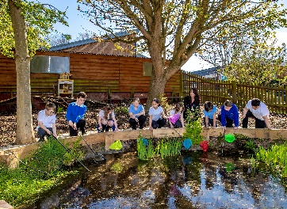

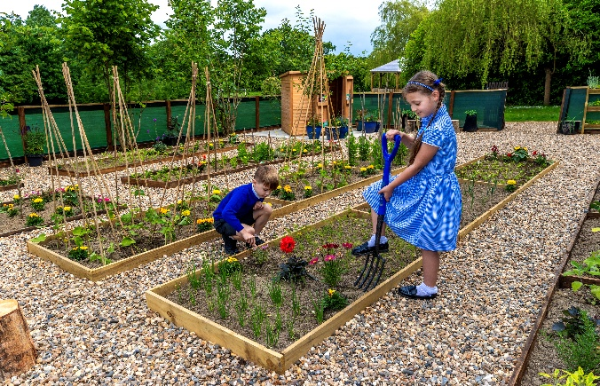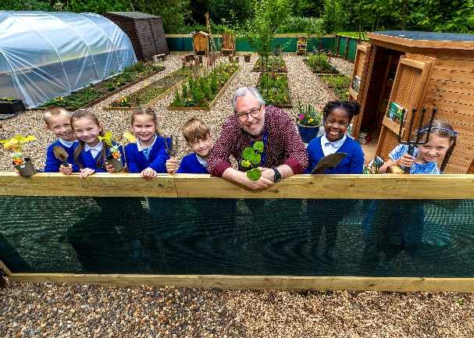

Positive Playtimes

Learning is our main priority here at GBJS; however, we understand the importance of development of social skills, brain breaks and 'down' time to allow the children to flourish when in the classroom. With this in mind, we have worked hard to provide the children of GBJS supportive outside spaces for them to enjoy positive playtimes and be ready for the learning. Our playgrounds have been painted with engaging and creativity-inducing markings where children can invent their own games and play creatively with their friends, making up fun games. During lunchtimes, children also have the opportunity to play with plethora of games and activities, such as, giant Connect Four, our Activall Boards or active games to name only a few. On alternating days of the week, during break time, football is an option for children in different year groups on the lower playground, too. It doesn't stop there - we also have a wooden activity/fit trail for children to use during the fair-weather months, an outdoor gym and a huge field for them to run off some excess energy and play with their friends. Additionally, we have a bouldering wall with four challenging routes to provide extra fun at lunchtime. For those children who prefer a quieter pace at break and lunchtimes, the Helping Hand playground and hut is the ideal place for them to find some peace and support if needed. With all of these options at break and lunchtimes, the children are guaranteed to find some fun and relaxation and, importantly, be ready for their learning.

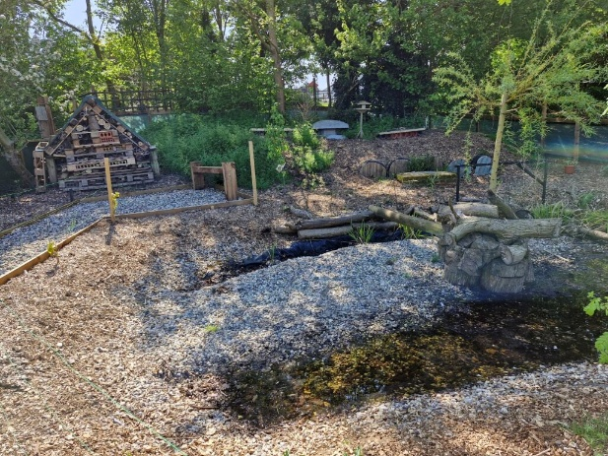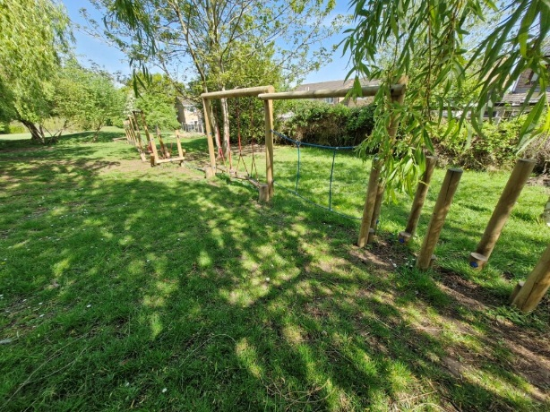

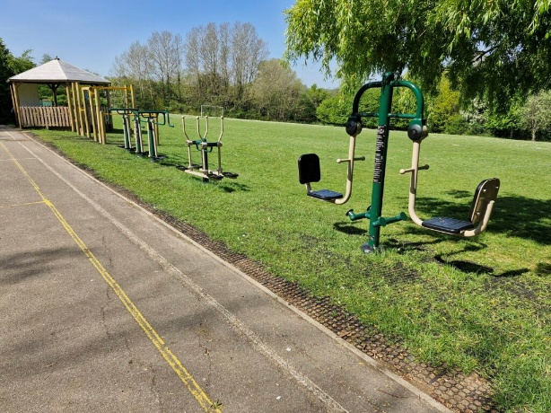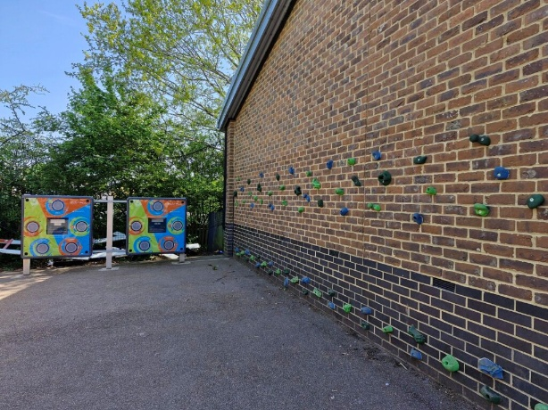

Celebrating Success
Recognising effort, achievement and celebrating success is vital in raising the self-esteem of our learners. Each Friday, during our celebration assembly special ‘Superhero’ certificates are presented to children who demonstrate our learning behaviours or for going above and beyond our Code of Conduct; sports stars are recognised for their success or involvement in competitions; a Pobble Champion is selected by the English lead to share their brilliant writing with the school and the reading ‘Millionaires’ are announced and presented with a prize book and bookmark; Times Table Rock Stars are recognised for making excellent progress with their times tables recall, improving their ‘rock status’ and speed; and our house point results for the week, term and year are announced, as well as children’s individual contributions being recognised. It is a positive, fun assembly and one which everyone looks forward to each week.

The Bradford Mile
The Bradford Mile is a safe, simple and measurable way to improve health and physical activity. Every pupil, regardless of ability, can get involved by walking with pace around the route to collect miles and increase fitness. Bradford Mile time is at the class teacher’s discretion, but children can also collect ‘miles’ during break or lunchtimes. Initiatives like this are supported by guidance from the Department of Health which advises that children should engage in regular daily physical activity habits across the week, every week of the year. 11 laps of our course equals one mile!

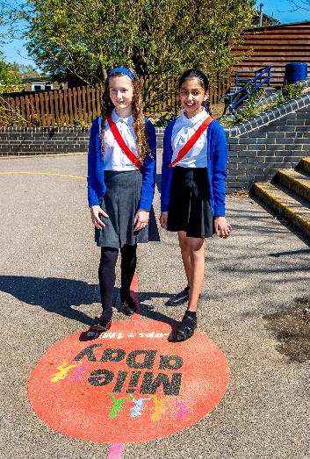

The Walk to School Challenge

The WOW Walk to School Challenge is something we are very proud to be involved in. WOW is a pupil-led initiative where children self-report how they get to school every day using the interactive WOW Travel Tracker. If they travel sustainably (walk, cycle or scoot) once a week for a month, they get rewarded with an eco-friendly badge in our half termly celebration assembly. For those families who live outside of the local area and commute by car, there is also the option to ‘park and stride’. It's that easy! Since its introduction, we have been first in Essex and in the top five in England out of 1500 participating schools.

Software


Used in school and for homework

Accelerated Reader (referred to as AR or Renaissance) is a popular program used in schools. The program does not teach reading skills or strategies; it is intended to encourage children to read independently, at their own level and pace. When a child has finished a book, they ‘quiz’ on it using the online platform during the school day. Teachers use these quizzes to track progress and set appropriate learning goals (targets) to reach each term. As they work towards their goal, a sunflower grows on their screen to allow them to see their progress. To encourage more reading, the AR system cleverly counts the words read in each book, too, and children are rewarded with a brand new book of their choice for reading each million-word milestone.


Used in school and for homework

Century is an incredibly intelligent online software that personalises content, questions and pathways for every learner in English, Maths and Science, allowing teachers to identify and address misconceptions and close gaps in children knowledge and understanding. It is a supportive system that stretches the child at a pace that is right for them. At GBJS we use this as a classroom and/or homework tool, and also offer after-school homework club for children to attend.


Used in school

PiXL is a valuable teacher tool which allows them to diagnose gaps in children’s learning through termly assessments and use ‘therapies’ to close those gaps quickly. It also allows the school to track the progress of every learner, measure our progress against other PiXL schools nationally and accurately report to parents the progress their children are making each year.


Used in school

Pobble is an educational platform designed by and for teachers to help improve children’s writing ability through the opportunity to see examples of other children’s writing to model their own on and through increased enthusiasm by becoming ‘pobblished’. Every week, your child's teacher will select ‘published authors’. Their work will be shared with the school community and a global audience. We ask you to join your child on this learning journey by engaging with their writing online by leaving a comment or ‘liking’ their writing. A weekly ‘Pobble Champion’ is selected by our English Lead and is shared during our weekly celebration assembly and in our Facebook group.

 Used in school and for homework

Emile is a Department for Education approved online platform to improve spelling skills by engaging children in a four-level online game process. We use this to support spelling through homework tasks.

 Used in school
We introduced Teams, initially, as a way to provide a home learning platform during the pandemic national lockdown. If for any reason we need to resort to home learning again, we will use this to deliver lessons and set tasks. It will have been explained to your child/children that the discussion board is not a chat facility and should not be used to talk with their friends. It is purely for work-based discussion, tasks and questions.



Used in school and for homework
Times Table Rock Stars is a fun and challenging programme designed to help pupils master the times tables. To be a Times Table Rock Star you need to answer any multiplication fact up to 12×12 in less than 3 seconds! The goal is for all participating rockers to be Times Table Rock Stars as soon as possible. As well as having opportunities during the school week, please see the homework guidance in this handbook for additional practice expectations.

 For parents

We are a cashless school so use ParentPay for all items requiring payment. This includes booking and paying for school meals, school trips, after-school clubs. All children at the Infant School receive free meals, however, if you think you may be entitled to these at Junior School you will need to apply at https://www.cloudforedu.org.uk/ofsm/sims Otherwise, all meals will need to be booked and paid for in advance. When your child starts with us, you will receive details on how to set up and use this system. If you already have a ParentPay account for a child at another school, you can add our school details to your existing account.

 For parents

This is our school Management Information System. Many of you will be familiar with it from the Infant School. There is a parent app which we would encourage you to download as it enables you to view information, update contact details for your child and receive communications from us.

Homework
As explained in our curriculum vision, we provide a curriculum which aims to be purposeful, motivating and inspiring. Homework is part of the curriculum learning process and is valued as a way of embedding knowledge and skills achieved in the classroom, but also for preparing for learning for future lessons. We use various e-learning platforms to provide homework, such as, Times Table Rock Stars and Century (see ‘Software’ section for more details), but, at times, we also make requests for research or project- based homework to be used in lessons. All homework expectations are communicated in an information sheet stuck into your child’s homework book or Reading Record at the beginning of the year. For more information about homework, please visit our website and read our Homework Policy.

Homework task | Benefits
Reading | Improved reading skills, enhanced writing skills, increased knowledge, better concentration and focus, relaxation and stress relief
Times Table Rock Stars (TTRS) | Improved recall of times tables facts, increased motivation and engagement, enhanced problem-solving skills, personalised learning
Emile for Spelling | Improved recall of spelling rules, increased motivation and engagement, enhanced problem-solving skills, personalised learning
Century nuggets | Increased motivation and engagement, enhanced problem-solving skills, personalised learning

Year | Reading | Spelling: Emile | Maths: TTRS | Century nuggets
3 | 20 mins x 5 per week | 10 mins x 5 per week | 10 mins x 5 per week or 500 points | 1 (starting from Spring 2)
4 | 20 mins x 5 per week | 10 mins x 5 per week | 10 mins x 5 per week or 500 points | 2
5 | 20 mins x 5 per week | 20 mins x 1 per week | 20 mins 1 x per week or 500 points | 3 nuggets
6 | 20 mins x 5 per week | 20 mins x 1 per week | 20 mins 1 x per week or 500 points | 4 nuggets

Pupil Voice in Action
Global Green Team
When the children reach Year 5, they are able to apply to be part of our Global Green Team. Children involved in this group meet to consider ways in which we can become an eco-friendlier environment by looking after our school and local community. They get involved in special projects and take action to combat climate change.
House Teams
All children are allocated a ‘house’ team at the beginning of their junior school journey. Our house names were decided in collaboration with the children and it was felt that they were symbolic of the attributes to aspire to as a member of the Great Bradfords Junior school community. These are: Air, Fire, Water and Earth. Belonging to a house and contributing towards collective house points, allows the children to create a bond with a team and share successes together. House points are awarded by adults in the school for reasons ranging from demonstrating any of our superhero learning behaviours to keeping their classroom tidy.
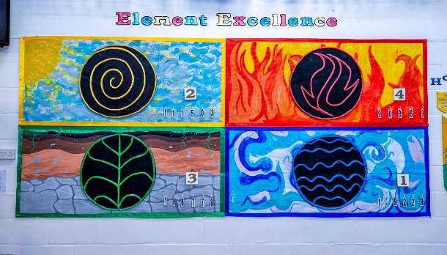
Pupil School Council
At Great Bradfords Junior School, we believe that children should be listened to and have the opportunity to have their voices heard. Each year, every pupil in every class is given the chance to lead their class as a Pupil School Council representative. The voting process is similar to the democratic one in central government where each candidate presents their pitch to their class and then the classes vote anonymously for their preferred candidate. The winner will be awarded with a badge and be expected to commit to weekly pre-school day meetings, feedback to their class and contribute to sharing their classes opinions.
Antibullying Ambassadors
We are pleased to have over 20 Anti-bullying ambassadors trained across the school with representatives from every class. Although we are on a mission to eliminate bullying for good, if it does happen, we want to deal with this swiftly to ensure any unkind actions STOP. The Diana Award's Anti-Bullying Programme trains young people to become anti-bullying ambassadors in their schools and communities. These ambassadors are then able to lead initiatives and campaigns to promote kindness, respect, and inclusivity, and to support those who have experienced bullying.

Working Together as a Community
Parent Forum
We are, as a school, invested in working with partnership with our families and feel strongly about developing these relationships for the benefit of our children and community. As such, we have successfully achieved the Leading Parent Partnership Award (LPPA). Although this award recognises our commitment to parental engagement with our school with a certificate, the main benefit and reason for proceeding through this process, was to help us to audit our current provision and allow us to identify next steps for developing and improving our school/home relationships - which is what makes the most impact for our young people. As part of this process, we set up a Parent Forum, in which Parents/Carers can inform, and be informed, about the decision-making process which could not just help but improve home/school relationships, give a voice to our parents and carers and provide support for one another.

Pastoral and Mental Health Support Team
At the core of our decision-making for supporting our most vulnerable children is our Children and Family Team (CFT). This team meets regularly to ensure that every child feels safe, supported, and cared for both in and out of school. All members of the CFT are trained mental health first aiders and include the headteacher (Designated Safeguarding Lead), deputy headteacher (Disadvantaged Champion, Deputy Designated Safeguarding Lead, and Senior Mental Health Lead), SENDCo, administration manager, and our inclusion, pastoral and behaviour leads. These professionals are highly trained, experienced, and qualified in supporting children with social and emotional wellbeing challenges. To aid their work, we have well-resourced, dedicated spaces within the school — the Rainbow, Star, and Oasis rooms — where children can access targeted support. This includes sessions like 'Zones of Regulation', which help children learn to identify and manage their emotions independently.
As well as the support offered by our team, we are very lucky to be able to offer more in-depth support for children, where needed, through our links with the NHS Mental Health Support Team (MHST). The team deliver workshops for parents, children and staff over the school year as well as working individually to support specific families in our school.
PTFA
The Parent, Teacher and Friends Association (PTFA) work together to support the school with fun, interesting events to raise much needed funds for the school. You may be interested to know that all parents are automatically part of the team as your child is part of our school; however, it is your engagement that counts! Please contact the school via admin@gbjs.co.uk to register your interest in getting involved with organising future events and supporting the school in this way.

Wraparound Provision and clubs
CMXSC offer both breakfast club, from 7.30a.m. and wraparound care until 6.00p.m. They also offer holiday camps at our school. During Wraparound sessions various activities are available including dodgeball, cooking, science and Nerf Battles. Places can be booked here:
https://www.cmxsc.co.uk/
Our school offer a Homework Club each day where children can complete their homework with the support of school staff and ICT access. This can be booked via the school at the start of each term. It is free and places are limited to one night per child, per week. We also have a choir that have the opportunity to sing at the Young Voices concert at the O2 in January along with other events, and a Gardening Club which helps to look after our allotment and grounds.

Our School Day

- Breakfast Club - Booked and paid for in advance via CMXSC –  https://www.cmxsc.co.uk/ | 07:30 – 08:35
Doors open (children should not arrive before this as they will be unsupervised) | 08:35
Registers taken (children arriving after 08:45 are late and will need to enter via reception). | 08:45
Break | 10:30-10:45
Lunch – staggered by year group (children have a 55-minute break during this time) | 11:45-13:00
End of school day | 15:15
- Wraparound Care - Booked and paid for in advance via CMXSC - https://www.cmxsc.co.uk/ | 15:15-18:00

If you meet your child at the end of the school day, please arrange to meet them at either of our Parent Waiting Areas.

Medical Matters
Our first aid procedures are informed by Essex County Council Codes of Practice and we monitor them regularly. However, we are only able to administer basic first aid and if the injury sustained cannot be treated adequately, we always contact the parents, or the child’s G.P. if the parent cannot be contacted.
In the case of sickness, or an accident, every effort will be made to contact you. This is why it is essential that we have a current address and telephone number where you can be reached during the day.
The school is happy to consider requests from parents for administering medicines, both prescribed and non-prescribed. In the interests of all the boys and girls in the school, it is essential that the medicine request form is completed before the medicine is brought into school. Each request should be made in writing (using the appropriate form which is obtainable from the School Office).
All medication should be handed in by an adult at Reception. Inhalers will be kept in the medical room where it is readily available to your child when required. During school visits, and P.E. lessons on the school field, teaching staff will have the required medication with them.
In exceptional circumstances, some children with long term medical needs require further support from the school. For these children an individual Health Care Plan is drawn up in conjunction with the parents and, where appropriate, the medical profession. If you feel your child needs this medical support in school, please contact the school office in the first instance.



Uniform
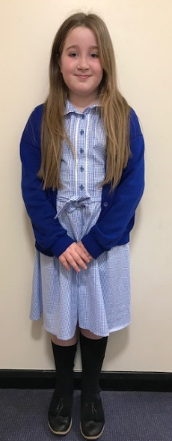 | 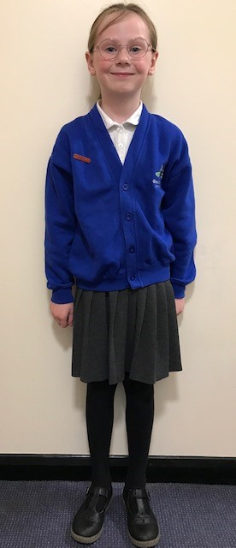 | 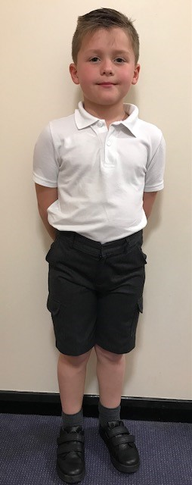 | 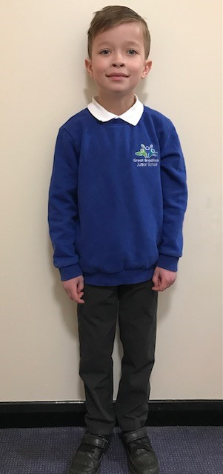

We encourage all our children to wear the school's uniform. It is not only smart and practical, but gives the children a sense of belonging and of being important members of the school community.
The Government asks school governing bodies to ensure that the uniform chosen is widely available in high street shops and other retail outlets, rather than from an expensive sole supplier.
- Royal blue sweatshirt or cardigan with white polo shirt;
- Grey or black trousers/skirts;
- Blue and white summer dresses for girls;
- Black shoes or black trainers – no boots or trainers of any other colour;

Royal blue is a colour that is easily accessible from retail outlets.
Our designated uniform supplier is MyClothing.com. Their school embroidery service supplies sweatshirts, polo shirts and fleeces with the embroidered school logo. These goods will be delivered direct to your home.

It is extremely important that you name all uniform items of clothing. As you can imagine, missing items without names are extremely difficult to find!

P.E. Kit

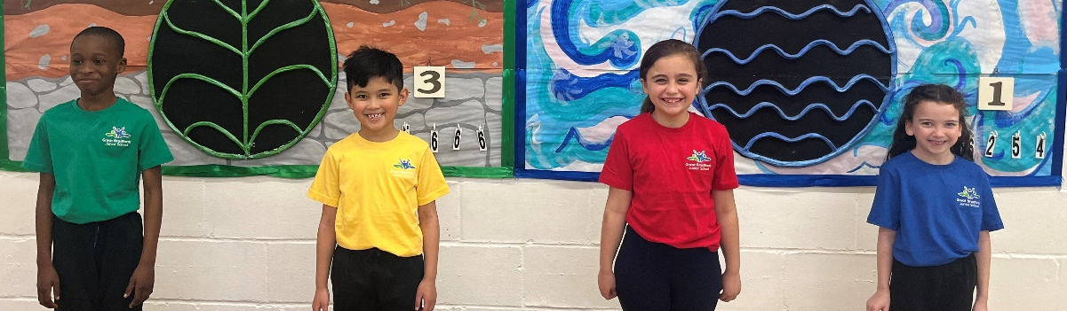

All children taking part in P.E./Games will need appropriate, clean P.E. clothing, which provides a freedom of movement and, when necessary, some protection from the weather. Our children come into school on P.E. days wearing their kit:
- House colour T shirt
- Loose-fitting black shorts (not cycling shorts)
- Black, white or house colour socks
- Black jogging bottoms (not leggings)
- Black sweatshirt for winter (no logos)
- Black or white trainers.

PLEASE NOTE:

Children should wear their school sweatshirt/jumper/cardigan over their P.E. T shirt along with their shorts/tracksuit bottoms during the lessons which are not P.E. lessons then change into their P.E. sweatshirt/jumper for their P.E. lesson. Your child’s P.E day will be notified to you at the beginning of the year.

Important Information
Jewellery is not suitable for school wear, but named watches may be worn (NOT smartwatches). Watches will need to be removed for P.E. Children with pierced ears may wear one pair of plain small studs. However, during P.E. and swimming we require all children to remove their earrings for safety reasons. If this causes difficulty, when your child has P.E. or swimming, please ensure that your child does not wear earrings to school that day. If your child is unable to remove their earrings they will not be allowed to go swimming or take part in P.E. lessons, both of which form part of the statutory curriculum. To assist you, your child's class teacher will inform you of P.E. and swimming times. If you are planning to have your child’s ears pierced, we would recommend doing this at the start of the summer holidays to allow time for the ears to heal.

Other important equipment needed for the school day
- A labelled, reusable water bottle (water only - no juice).
- A snack for breaktime (preferably fruit or vegetables) if desired.
- A small pencil case containing a pencil, blue biro pen, ruler and rubber. (This will need to fit into their tray so cannot be too large!)
- Reading Record, reading book and Homework book (these are provided by the school but need to be brought in every day).


At Great Bradfords Junior School, in line with our Code of Conduct, children are encouraged to take responsibility for their belongings by keeping them tidy and safe. As such, we provide them with a box which is linked to their ‘house’ (Air, Earth, Fire or Water) to store their belongings during the day.
To support your child being able to independently pack their box on a daily basis, we have provided the dimensions of the box below. This enables parents/carers to make suitable purchases for school bags, small lunchboxes, and coats.

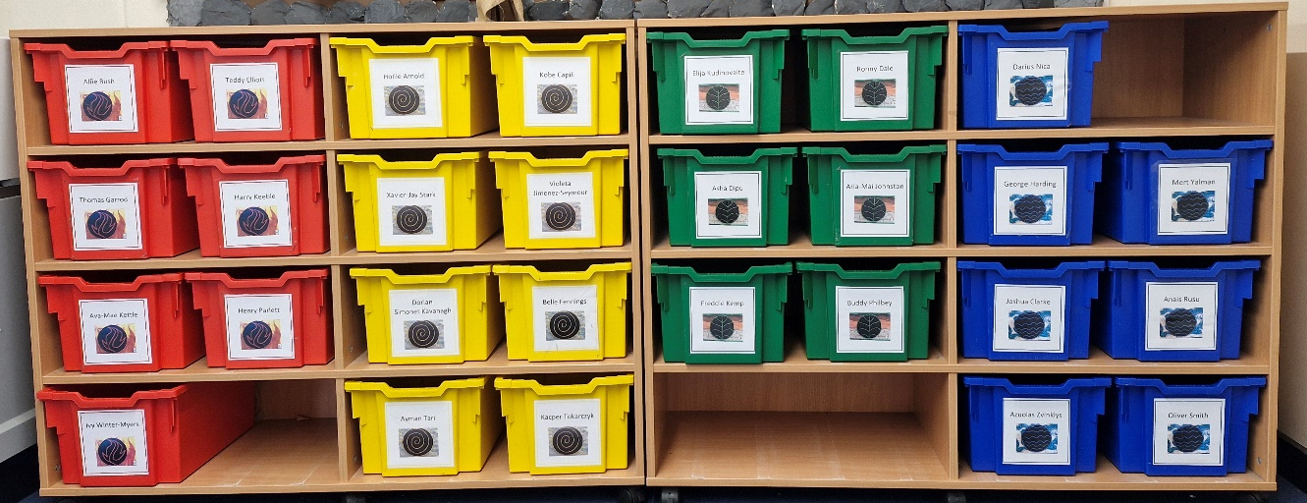
Each box measures 36cm by 27 cm

Attendance/Absence procedures
If a child is absent from school, the parent/carer must follow the following procedures:

• Contact the school on the first day of absence before 9.30 am. The school has an answer phone available to leave a message. If nobody is available to take your call, you can email admin@gbjs.co.uk or call into school personally and speak to the office staff.
• Contact the school on every further day of absence, again before 9.30am
• Ensure that your child returns to school as soon as possible and provide any medical evidence if requested to support the absence.

If your child is absent, we will:

• Telephone you on the first day of absence if we have not heard from you; however, it is your responsibility to contact us
• Write to you if your child’s attendance is below 90%
• Invite you in to school to discuss the situation with our Attendance Champion, Child and Family Support Worker or Headteacher if absences persist
• Refer the matter to the Local Authority for relevant sanctions if attendance deteriorates following the above actions

First day calling:
The school operates a first day response to absence: we will call you if we have not heard from you in the first instance. If we are unable to make contact with parents/carers by telephone, we will telephone emergency contact numbers, send letters home and a home visit may be made in the interests of safeguarding. A referral will be made to Local Authority if no contact has been made with parent/carers by the 10th day of absence, at which point your child will be considered Missing from Education.

Term Time Holidays:
There is no entitlement for you to take your child on holiday during term time. You will be fined for taking your child on holiday during term time without consent from the school if the holiday exceeds 10 sessions (or 6 sessions in the month of September).
Absence during term time should be avoided because children can fall behind with their work and may find it difficult to integrate.
An application for leave must be made in writing to the school, detailing the exceptional circumstances.
The headteacher must be satisfied the circumstances warrant the granting of leave. Leave of absence will not be granted during term time unless there are exceptional circumstances. They will determine the number of school days a child can be away from school if the leave is granted.
If you do not apply for leave of absence in advance, the absence will be recorded as unauthorised. If your child is away for longer than was agreed, any extra time is recorded as unauthorised.

Medical appointments, where possible, should be out of school hours. Where this is not possible evidence of the appointment will be required in order to authorise the absence.

Admissions process for Great Bradfords Junior School
Primary Admissions Application
(i.e. applying for a place in Year 3 for September of the following Year. This is done between November and January.
Mid-year applications
(i.e. applying for a place to transfer from another school or because you have just arrived in the UK)

Apply for a place on the Essex County Council website:
https://www.essex.gov.uk/topic/admissions
They will contact the school to find out if we have a place available.

If your child attends another Infant School, we will be in touch to invite you to the transition events.
If your child currently attends Gt Bradfords Infant and Nursery School, an information pack will be sent home with your child. There will be a series of transition events organised between the two schools.
You will receive notification on the National Offer Day (usually in April), of the place.
Contact the school (01376 326739) to arrange a visit and a start date.
You will receive notification from Essex County Council if a place has been offered.

Contacting the school

Leavers process for Great Bradfords Junior School
Secondary Admission application
(i.e. applying for a place in Year 7 for September of the following Year. This is done between September and October.
Mid-year transfer to another school
(i.e. applying for a place to transfer to another school)

Apply for a place on the Essex County Council website:
https://www.essex.gov.uk/topic/admissions
They will contact the school to find out if there is a place available.

Meetings and transition events for the new school will be communicated to you by the secondary school.
You will receive notification on the National Offer Day (usually in March), of the place.
Contact us to obtain a Leavers Form, letting us know the new school details, your new address (if applicable) and the date your child will be leaving.
You will receive notification from Essex County Council if a place has been offered.

Contact Information
Office hours: 08:15 to 16:30
Phone: 01376 326739
Email: admin@gbjs.co.uk
Website: https://gtbradfordsjuniorschool.org.uk/
Facebook: We have a Facebook closed group. Please note this is only used for the school to share information and celebration; not as a communication channel.

If you have reason to raise a concern, please refer to our Compliments, Concerns and Complaints Policy on our website.

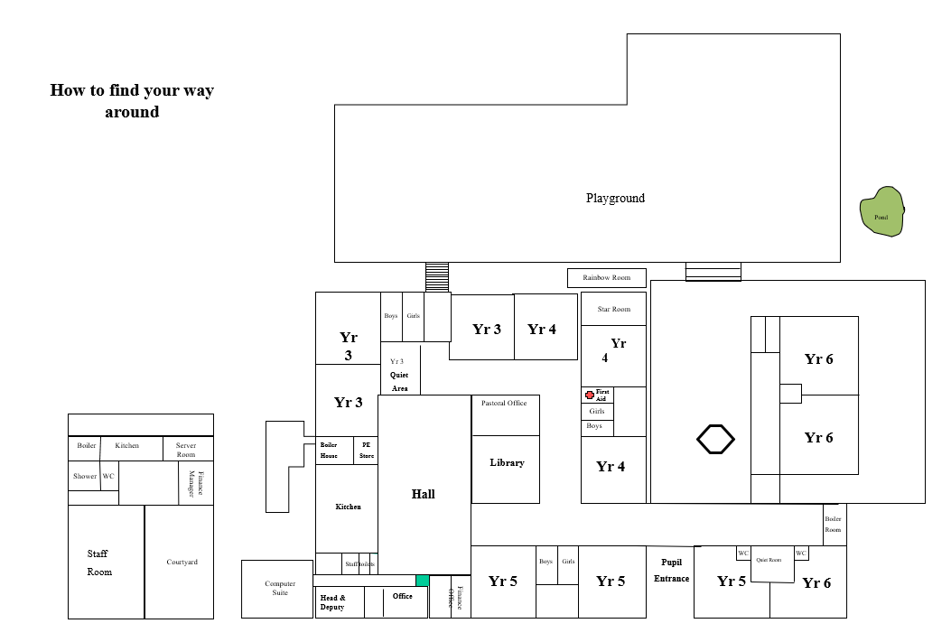
Site Map

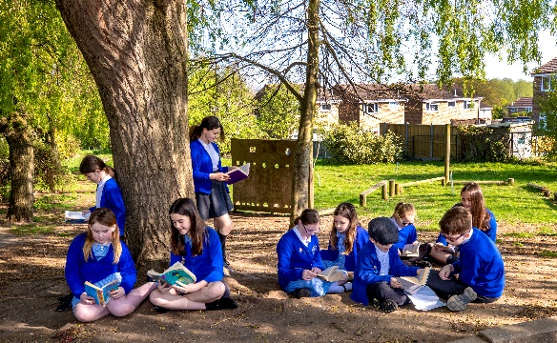
Together we learn;


together we grow



