What might I like to get better at….
Running
Learning new recipes
Drawing

My job is called a Mental Health Practitioner.
I work with children, young people and their families to support well-being.
Normally I see children, young people and their families in their schools, but I can also meet them online over a video or phone call.

Hi I am Vicki
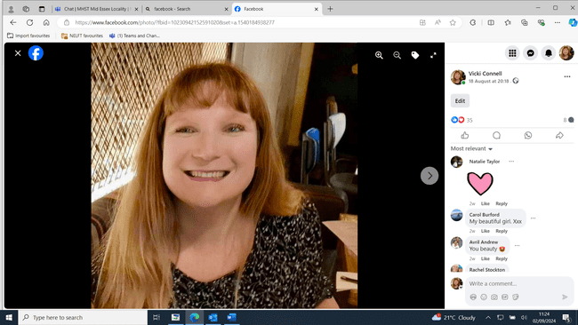

What is important me….
My family
My pets
My friends
Being kind
Being in nature

Here are some feelings that I might help you with…..
What might I do to help you at school?
Support you if you are experiencing low mood or worries.
Help you understand your feelings and finding ways to manage those feelings.
Work out what is going well for you and what you would like to change.

Nervous
Frustrated
Angry

Sad
People describe me as….
Kind
Calm
Supportive

Anxious
Confused
Worried
Overwhelmed

