What might I like to get better at….
Time management, especially in the morning.

My job is called a Mental Health Practitioner.
I work with children, young people and their families to support well-being.
Usually is meet with children, young people, and their families in school, but it is possible online over a video or phone call.

Hi, my name is Melissa
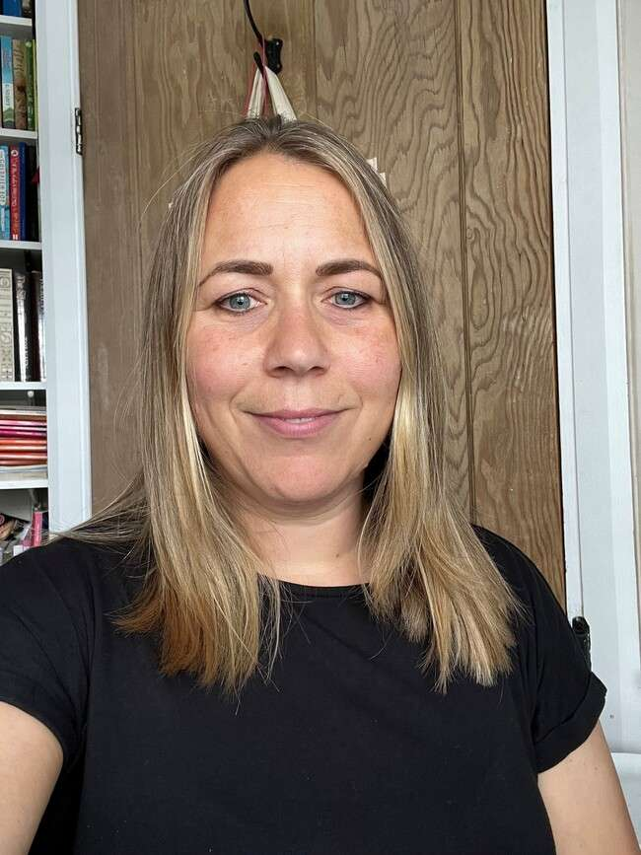



What is important me….
Doing things that make me feel happy like being with my family and friends, doing exercise and being outdoors with nature.


Here are some feelings that I might help you with…..
What might I do to help you at school?
Support you if you are experiencing low mood or feelings of worry/anxiety.
Help you in understanding your feelings and finding ways to manage them.
Find out what is going well for you and what you would like to change.

Nervous

Frustrated
Angry

Sad

People describe me as….
Smiley
Caring
Supportive
fidget

Anxious
Confused
Worried
Overwhelmed

