What might I like to get better at….
Swimming
Baking
Time keeping

My job is called a Mental Health Practitioner.
I work with children, young people and their families to support well-being.
Normally I see children, young people and their families in their schools, but I can also meet them online over a video or phone call.

Hi I am Eleni

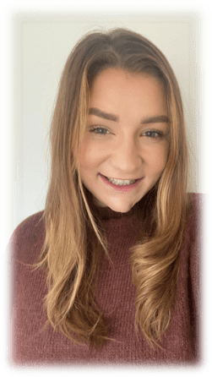


What is important me….
My Friends and Family
Helping others
Self-care
Animals especially
dogs
And FOOD!


Here are some feelings that I might help you with…..
What might I do to help you at school?
Support you if you are experiencing low mood or worries.
Help you understand your feelings and finding ways to manage those feelings.
Work out what is going well for you and what you would like to change.

Nervous

Frustrated
Angry

Sad

People describe me as….
Fun
Kind
Curious
Supportive

Anxious
Confused
Overwhelmed
Worried

